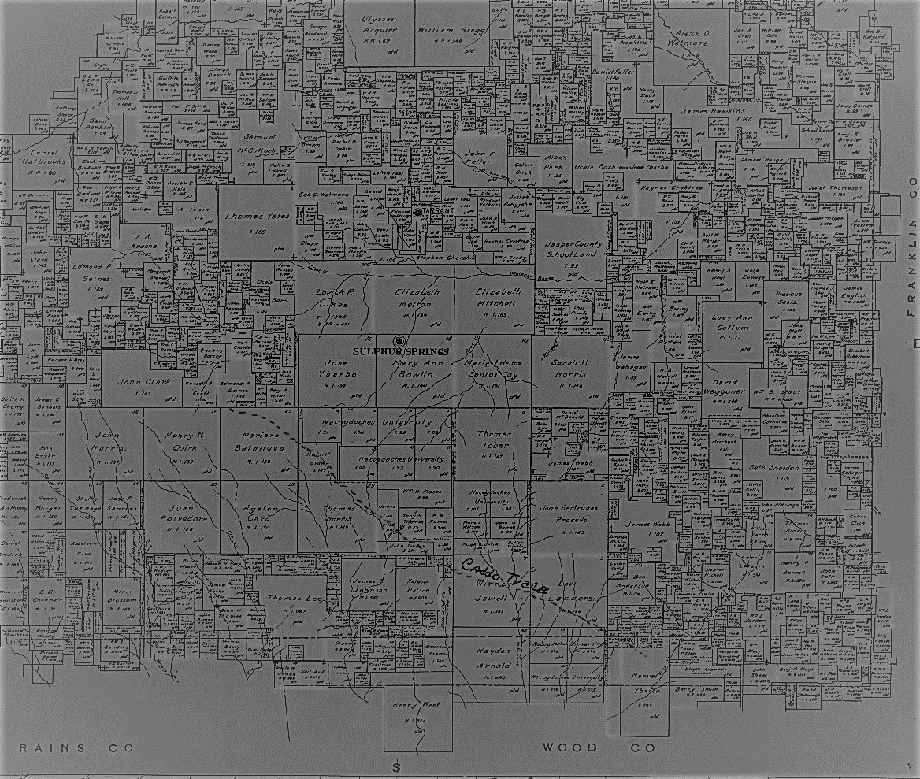

***Our Story***

The Hopkins County Genealogical Society was formed in 1980 with 15 members. Now with about 200 members, copies of our 40-page award-winning Quarterly are printed for mailing to members and exchange societies across the nation.

**Community Events:** Our meetings are the third Thursday of each month, except June, July, and December, at 7:00 pm in the research library featuring outstanding speakers promoting history and genealogy. In addition, HCGS hosts a yearly Lock-In in July and a Cemetery Walk in the fall.

Our Archives house original county records, maps, family collections, scrapbooks, 1000’s of photographs, and numerous original materials.

With over 8,000 titles in our collection, it’s never been easier to start searching!

***Welcome to our Research***

***Library and Archives***

Volunteer members are on duty to assist you in locating materials. Members of the Society will be glad to respond to specific requests and answer queries if patrons will send an SASE to P.O. Box 624, Sulphur Springs, TX 75483-0624 or an email to [hcgstx@suddenlinkmail.com](mailto:hcgstx@suddenlinkmail.com).

We are located at 611 N. Davis St., Sulphur Springs, TX, 75482 in a space adjoining the Sulphur Springs Public Library.

***Research Library***

611 North Davis Street

P. O Box 624 75483-0624

Sulphur Springs, Texas 75482

903-885-8523

**Visit our website at:**

**www.HCGSTX.org**

**Email:**

[hcgstx@suddenlinkmail.com](mailto:hcgstx@suddenlinkmail.com)

**Hours:**

M, T, Th, & F 9am-5pm

Sat 9am-12pm

Wed & Sun Closed

**Like us on Facebook at:**

Hopkins County

Genealogical Society

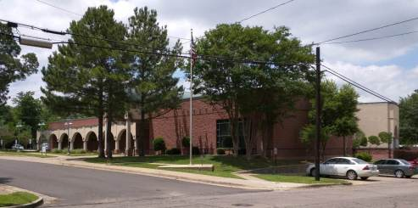

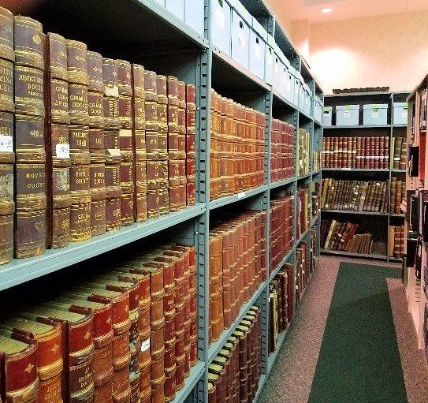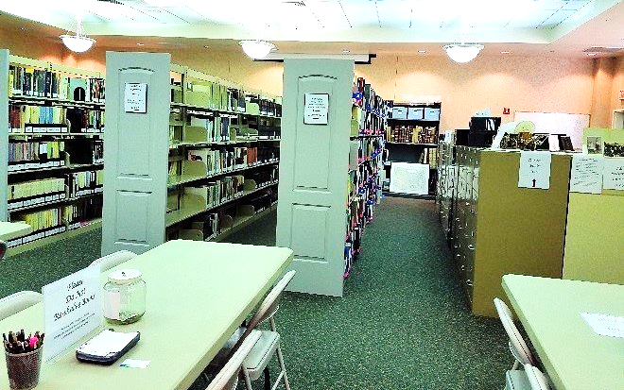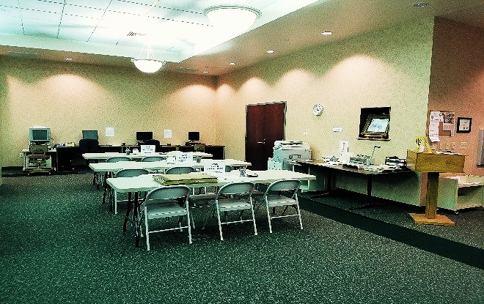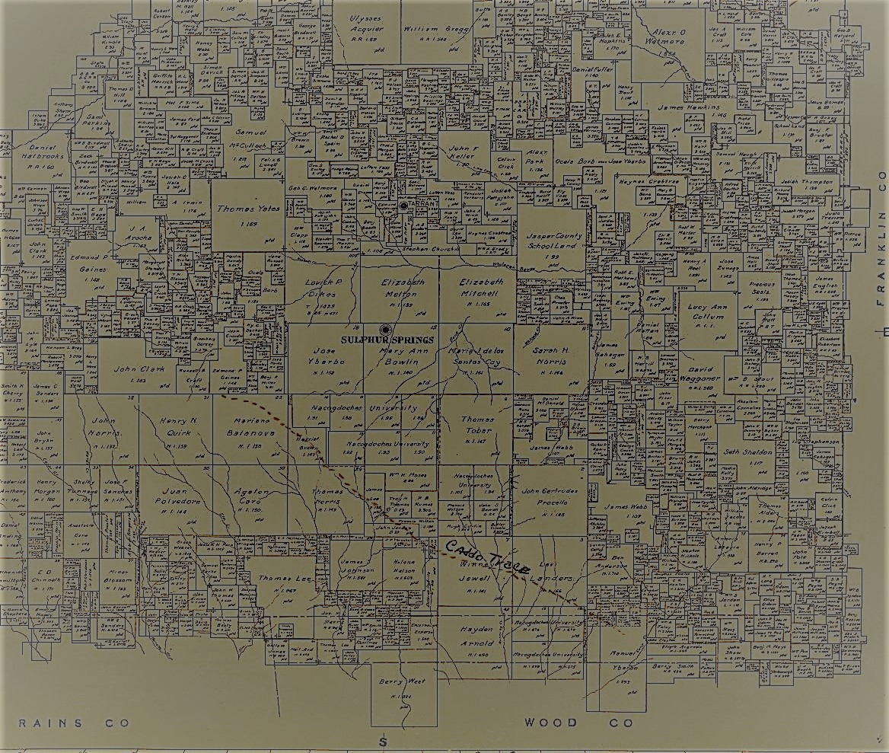­

* Find A Grave
* Family Search
* Ancestry.com World Edition
* Fold3.com
* GenealogyBank.com
* NewspaperArchive.com
* Newspapers.com
* The Portal to Texas History

***In-House Resources***

HCGS offers many in-house resources free of charge to our patrons. including:

HCGS is an affiliate library of the LDS in Salt Lake City, Utah, which houses millions of digitized restricted records covering most counties in the US as well as worldwide. These Images allow our patrons to travel to locations and view many records including court house records such as deeds, wills, probate cases, etc. from the convenience of our HCGS library.

Our microfilm collection contains census, Hopkins County records, some adjacent county records, and Hopkins County newspapers.

Our extensive Hopkins County collection includes vertical and surname files as well as veterans’ records.

We have computers with internet access dedicated for research use at no charge.

***Your Support Matters***

* Allows us to continue to grow and improve our collection.
* Helps us preserve Hopkins County history for future generations.
* Funds our library’s daily operation.
* Helps us provide an award winning website filled with Hopkins County genealogical information, Society updates, and useful research tips.
* Provides Northeast Texas with a quality research facility
* Allows us to purchase state of the art equipment such as computers and our new Scanpro 3000 microfilm reader.

There are many ways to support our library including donations, volunteering in the library or on special projects, and **especially** by becoming a member.

Memberships are for the calender year running from January to December.

Individual Memberships $20.00

Family Memberships $25.00

Dues include receiving our quarterly ***Hopkins County Heritage*** and access to Members Only content on our website containing thousands of county records.

***Become a Member!***

***Online Resources***

To access our online content

visit our website:

www. HCGSTX.org

Entire site is word searchable

as are most of the databases.

* Online Library Catalogue 24/7
* Links to helpful information
* Inventoried Archives
* Upcoming Events
* Research Services
* Society Information
* HCGS Publications for sale
* Applications for Pioneer and

First Family Certificates

* Cemetery Records
* Online Records
* Membership application
* Members Only Content –

Be sure to click this to see

what is available. And check back often as we continue to add more databases.